ChannraingseyYek

September 30, 2013

ET 260 Solid State I

Chapter 4: Diode Circuit

**Problem 1-23 odd**

# 1. What is the peak output voltage in Fig. 4-36a if the **diode is ideal**? The average value?The dc value? Sketch the output waveform.

Vpeak = VRMS / 0.707  
 = 50V/0.707 = 70.72 Vp

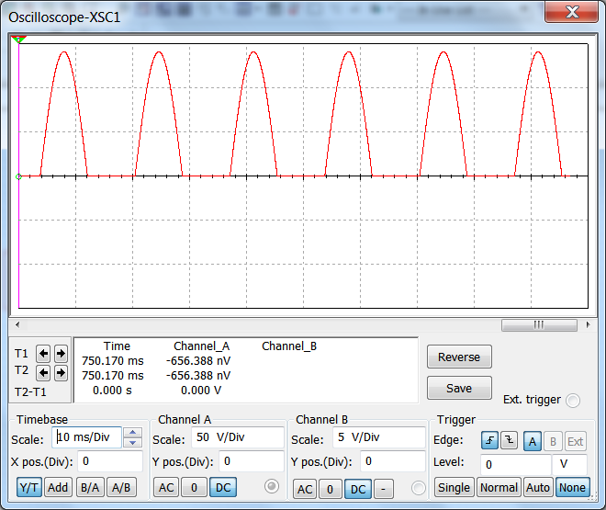 For ideal diode, we assume that there is no voltage drops across .the diode. Hence, Vp (out) = Vp (in) = 70.72 Vp  
 Vdc = Vp / π = 70.72V / π = 22.51 Vdc Vavg = Vdc = 22.51 Vdc

The function generator and the virtual diode   
component are used to display the waveform.

# 3. Repeat problem 1 using the second approximation of a diode.   
In the second approximation, we take the voltage drop across the diode into consideration.   
Vpeak= 70.72 Vp  
Vp (out) = Vp (in) - 0.7V   
 = 70.72V - 0.7V = 70.02V   
V= Vp / π = 70.02V / π = 22.29 VdcVavg = Vdc = 22.29 Vdc

# 5.If a transformer has a turn ratio of 6:1, what is the rms secondary voltage? The peak secondary voltage? Assume a primary voltage of 120V rms.



$$\frac{ Np}{Ns}= \frac{Vp}{Vs}$$

VS = ( VP· NS ) / NP = ( 120 V × 1 )/6  
 = 20 Vrms

VS (peak) = VRMS / 0.707 = 20V / 0.707 = 28.3Vp

# 7.Calculate the peak output voltage and the dc output voltage in Fig. 4-37 using an ideal diode.

V2 = ( V1· N2 ) / N1 = ( 120 V × 1 )/8  
 = 15 VrmsVL (peak) = VRMS / 0.707 = 15V / 0.707 = 21.2 Vp (ideal diode)

Vdc = Vp / π = 21.2V / π = 6.75 Vdc

#9.In a center-tapped transformer, the voltage across upper half is equal to the lower half of the secondary winding.   
Vupper=Vlower = [ ( VP· NS ) / NP ] / 2 = [ (120V × 1) /4 ] /2 = 15 Vrms

VP = VRMS / 0.707 = 15V / 0.707 = 21.2 Vp

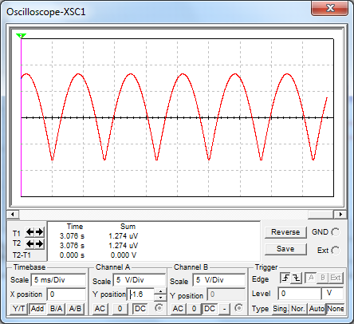# 11.V (sec) = [ ( 120 V × 1 ) / 7 ] /2 = 8.57 Vrms

Vp(sec) = 8.57V / 0.707 = 12.12 Vp  
VL = 12.12 V - 0.7 V = 11.42 Vp  
Vdc = 2 VL / π = 2 (11.42 Vp ) / π = 7.27 Vdc



# 13. V (sec) = [ ( 120 V × 1 ) / 8 ] = 15Vrms

Vp(sec) = 15V / 0.707 = 21.2 Vp  
VL = 21.2 V - 0.7 V - 0.7 V = 19.8 Vp  
Vdc = 2 VL / π = 2 (19.8 Vp ) / π = 12.6 Vdc

# 15.Vripple = (XC / XL) Vin = (25 Ω / 1kΩ ) × 20 Vp = 500 mVpp

# 17. Calculate the ripple voltage.



VS  = 120 V / 8 = 15 Vrms  
Vp = 15V / 0.707 = 21.2 VP  
Vout= 21.2 Vp - 0.7V = 20.5Vp  Vdc = Vp/ π = 21.2V / π = 6.75 Vdc  
IL = Vout / RL = 20.5V / 10 kΩ = 2.05 mA

Vripple= IL / ƒ·C = 2.05mA / (60Hz × 47μF) = 727mVpp

# 19.The ripple value will become double.

# 21.What is the dc output voltage in fig. 4-41? The ripple? Sketch the output waveform.  
VS  = 120 V / 8 = 13.3 Vrms  
Vp = 13.3V / 0.707 = 18.86 VP  
Vout= 18.86Vp - 0.7V - 0.7V = 14.46 Vp  Vdc = Vp/ π = 14.46V / π = 5.56 Vdc  
IL = Vout / RL = 14.46V / 1 kΩ = 14.46 mA

Vripple= IL / ƒ·C = 14.46mA / (120Hz × 470μF) = 256mVpp

# 23.What is the peak inverse voltage in problem 21?  
The peak inverse voltage is the specified maximum voltage that a diode rectifier will block.  
For bridge rectifier: PIV = Vp= 18.86 V