David Velasco
ET 360
Professor Lopez
10/22/13
Lab 10 – Motor Speed Control

Introduction:
This lab is meant to allow us to control the speed of the motor through use of LabVIEW, a DAQ, and pulse width modulation. This require both a physical driver circuit and block diagram on LabVIEW that comes with a slider that allows us to control the length of the pulses that increase the speed of the motor.

Procedure:
Below you can see our block diagram which we created on LabVIEW as well as the physical setup required by this lab. Although in the picture the slider is at 0(because we were not running the program), the pulse shown would have sped up the motor greatly.

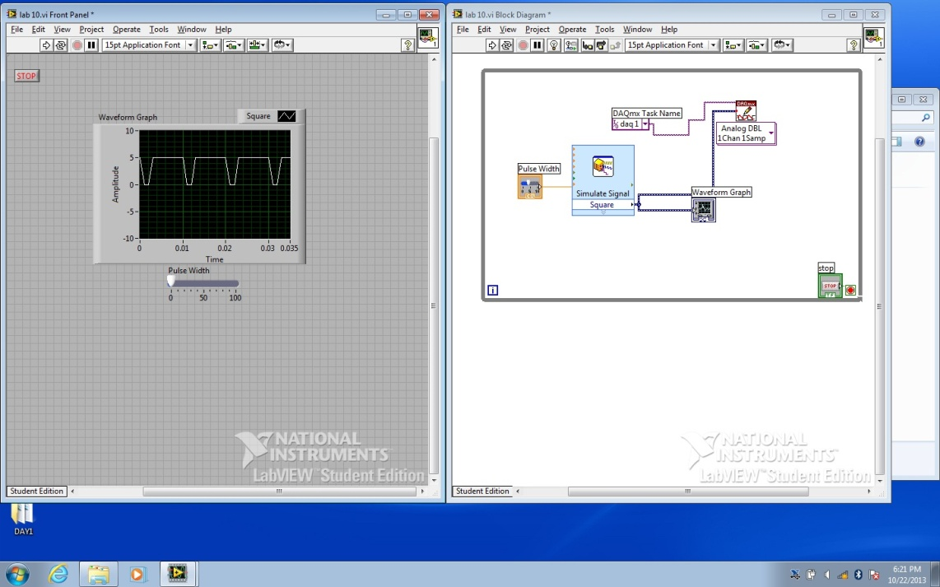

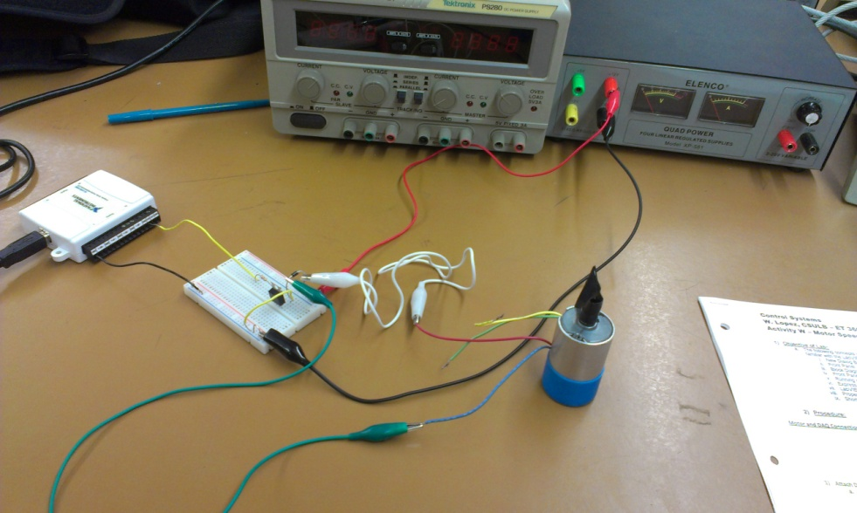

Conclusion:
This lab was very important in that it allows us to control a motor using electronic interfacing. I learned the driver circuit which is commonly used to power things like motors. This was the first time I had created a MAX task within LabVIEW. LabVIEW seems to be a very practical tool and quite understandable.

