Summary: In this lab we build a ce amplifier circuit. We will measure the voltage gain, dc, and ac waveforms in the circuit. When we attach a small signal into the base we can produce an amplified ac signal at the collector. This is seen in the waveform below where signal A produces a 10mVpp wave and signal B produces a 1.5Vpp waveform. This means that the circuit produces a gain of 150 by the voltage out which is signal B divided by the voltage in which is signal A.
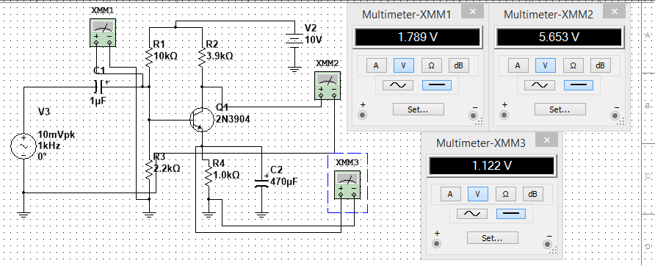

Signal A( signal at 0), Signal B( signal at division 2)
