California State University of Long BeaCH



|  |
| --- |
| ET - 341 Laboratory |
| Exp. 34: JFET Applications |

**Group**: Channraingsey Yek  
 RaamSundararaj

**Instructor**: William Lopez

**Date**: February 21, 2014

**Introduction:**

In this lab, we will practice some of the main applications of the field effect transistor. One main application is the analog switch that acts like a switch, which allows us to block or transmit an **ac signal**. We will also explore other applications such as voltage-variable resistance, voltage gain controller, and JFET chopper circuit.

**Procedure:**

We began with analog switch. As mentioned, this analog switch allows us to build circuits that either transmit an ac signal or block it from the output terminals from a push of a button. In this experiment, we try to transmit an ac signal 1 kHz of 100 mVpp. We see that it can fluctuate the signal from 100 mVpp to zero volt within seconds.

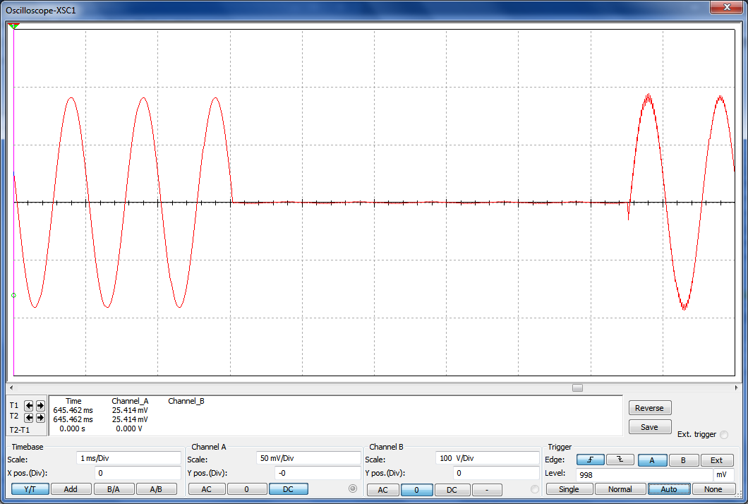

Figure 1. Analog Switch Circuit

When the VGS is zero, the JFET operates in the ohmic region with a resistance of RDS = 152.5Ω (value vary for each JFET). This value obtains by connecting the gate and the source lead, and measure with an ohmeter from drain to source.

 Chopper circuit as shown in figure 2 is a continouse square wave that continously switches on and off really fast.

Figure 2. JFET Chopper Circuit

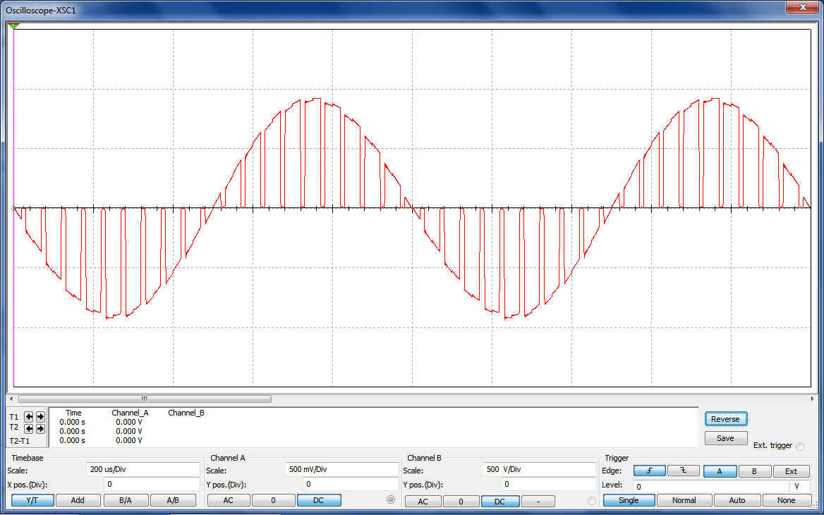

Figure 3. Multisim Chopper Circuit

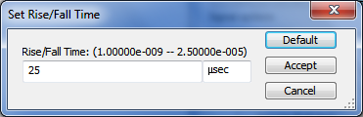

The Set Rise/Fall Time of the square wave generator must set to the 25 μsec to get a clean signal output shown on the oscilloscope in Figure 3.

Voltage-Variable Resistance Application

|  |  |  |  |
| --- | --- | --- | --- |
| VGG | Vin (mV) | Vout (mV) | RDS (kΩ) |
| -2.8V | 100 | 10 | 1.11 |
| -2.9V | 100 | 20 | 2.5 |
| -3V | 100 | 32 | 4.70 |
| -3.1V | 100 | 48 | 9.23 |
| -3.2V | 100 | 65 | 18.57 |
| -3.3V | 100 | 87 | 66.92 |
| -3.4V | 100 | 92 | 115 |
| -3.5V | 100 | 96 | 240 |

As we can see from the above table, the value RDS changes when the gate voltage VGG changes.

**Conclusion and Results:**

* The Analog Switch circuit allows us to build circuits that either emit an AC signal or block it from the output terminals.
* When a JFET is used in the voltage variable resistance circuit, we can change the value of rds(on) by changing the VGS.
* In the AGC circuit, we can build amplifiers whose voltage gain can be controlled by the AGC voltage.