Lab #10- Motor Speed Monitor with LabView Virtual Instruments

Andressa Ferraz
I.D: 013697201
Proffessor W. Lopez

Date: 10/14/2014
ET 360
Fall 2014

- Synthesis

- Front Panel and Block Diagram

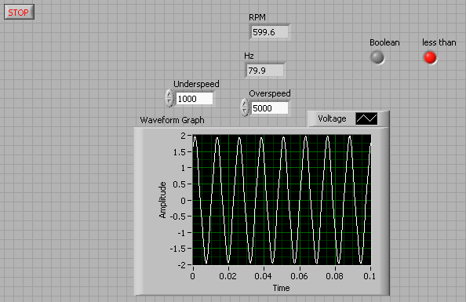

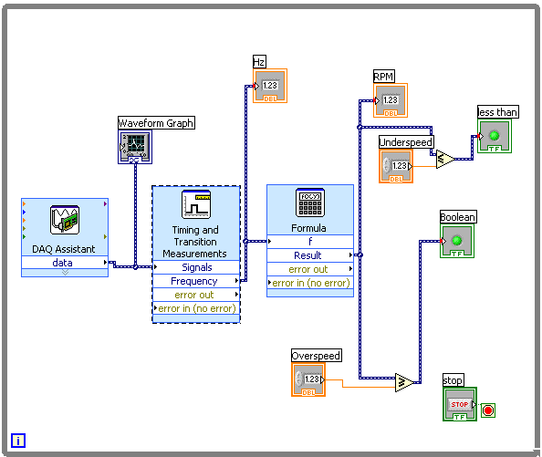

2. Analysis

- What type of input is this task? Explain.
This task is an analog input because it changes continuously. If the signal were 1 or 0 would be a digital task.

- What parameters of the motor used to calculate frequency?
The parameter of the motor that is used to calculate frequency is the rotation per minute (RPM).

- What is the result of having the wrong arithmetic comparison circuit?
If having a wrong arithmetic comparison circuit the LabVIEW will present error and shows some wrong numbers.

