**Sample Interview Questions**

1. **In the circuit below, what will the voltmeter read between points A and B.**



1. **In the circuit below what will the voltmeter read between points A and B**



1. **If the base to ground voltage( that is the voltage between points B and G) is 5v, what is the voltage at the emitter (voltage between E and G)**

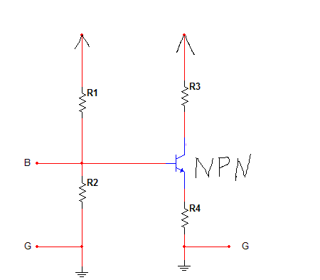

1. **What is wrong with this circuit shown below?**

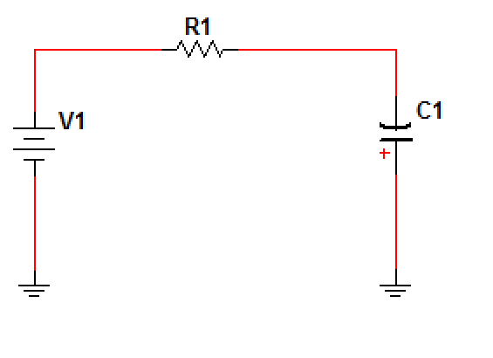

1. **What is the resistance between points A and B?**

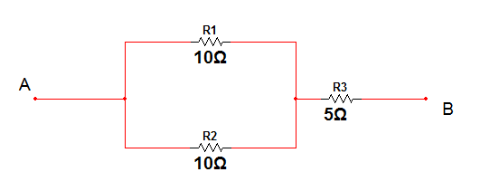

1. **What is the capacitance between points A and B?**

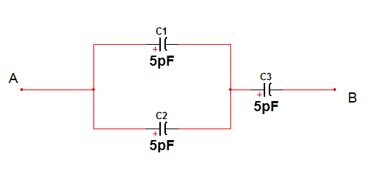

1. **What is the current through the resistor?**



1. **Which is the Anode and which is the cathode of the diode?**

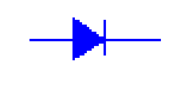

1. **In the circuit shown below, if the input to pin 2 is as shown below what does the shape of the output look like?**

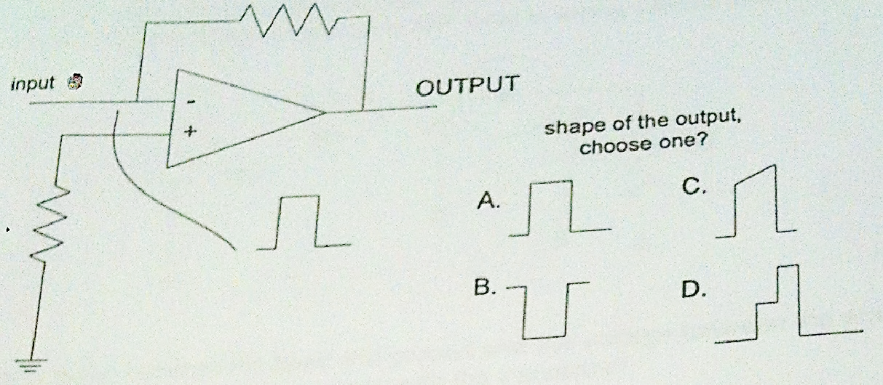

1. **In the transistor circuit shown below, if the input at the base is as shown, what does the output at the collector look like**

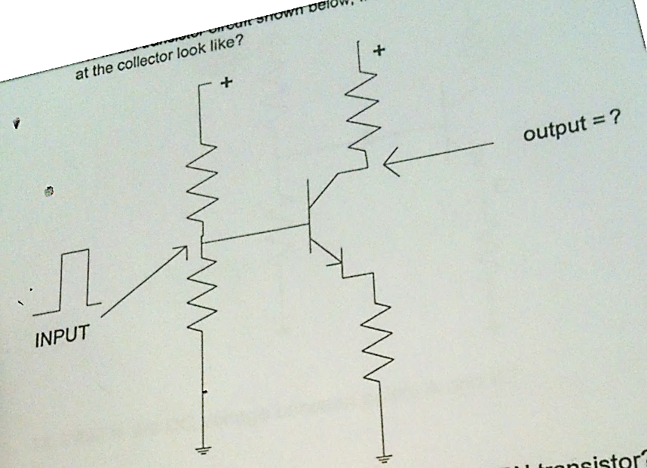

1. **Which is the PNP and Which is the NPN transistor?**

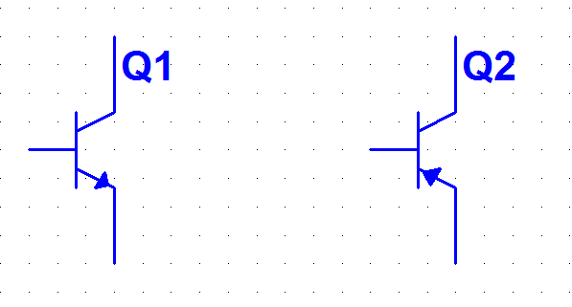

1. **A) if the voltage between point A and ground is the same as the voltage between B and ground. What is wrong with the diode?**

**B) if the voltage at point B is zero, what is wrong with the diode?**

**C) if the voltage at point A is 10V, what is wrong with the diode?**

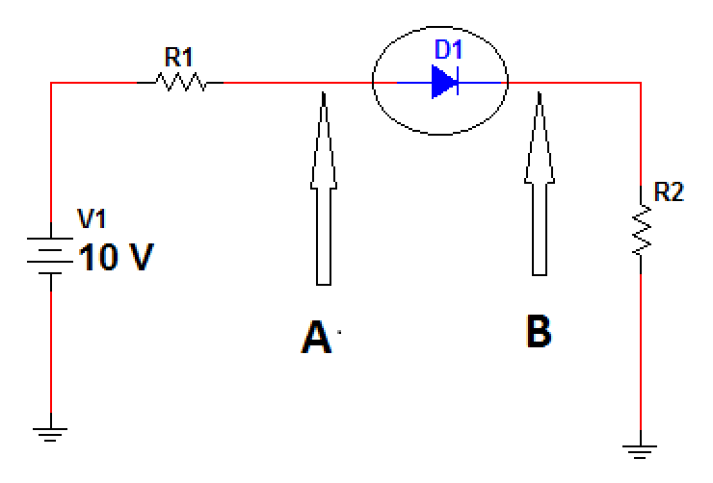

1. **if the voltage between the base and ground and the voltage between the emitter and ground are the same, what is wrong with the transistor?**

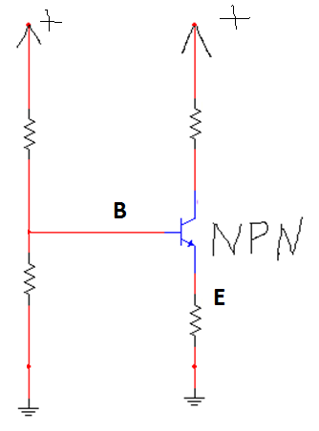

1. **what is the DC voltage between points A and B?**

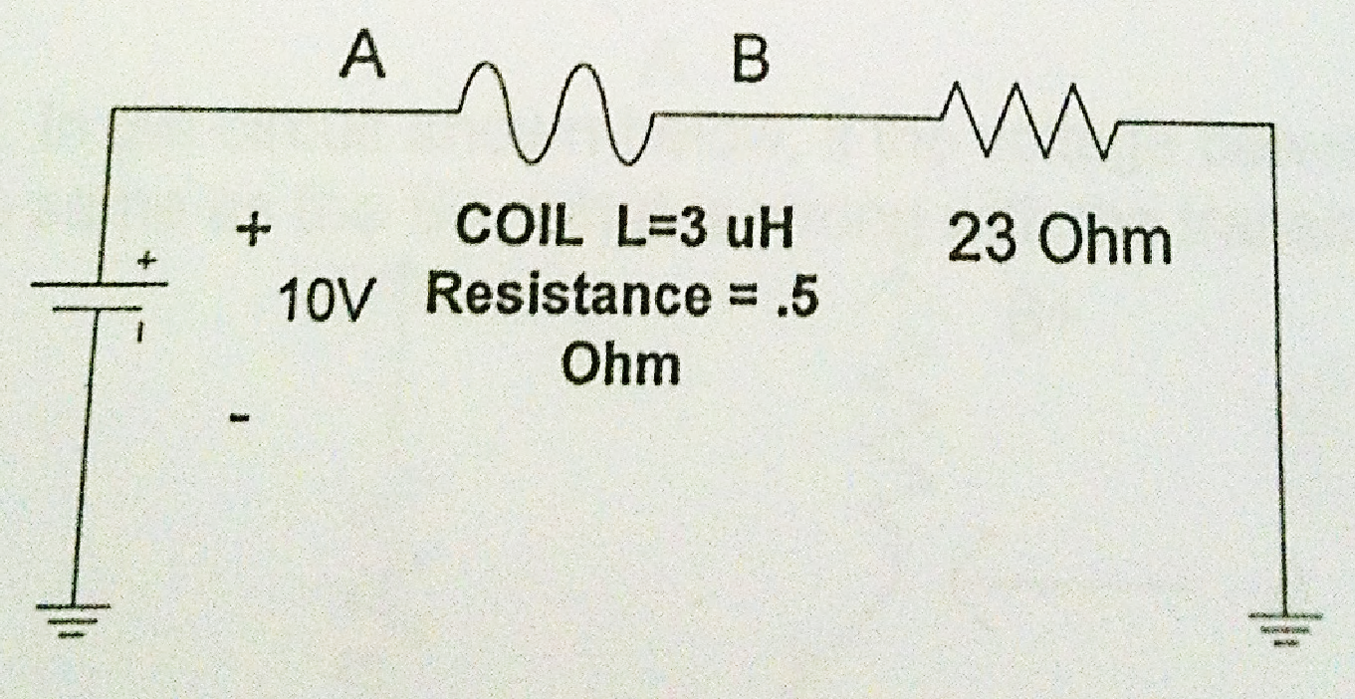

1. **after the switch of the circuit shown below has been closed for an hour, what will be the voltage across the capacitor? Draw a rough sketch of what the voltage waveform should look like at point B from time = 0 to 1 hour.**

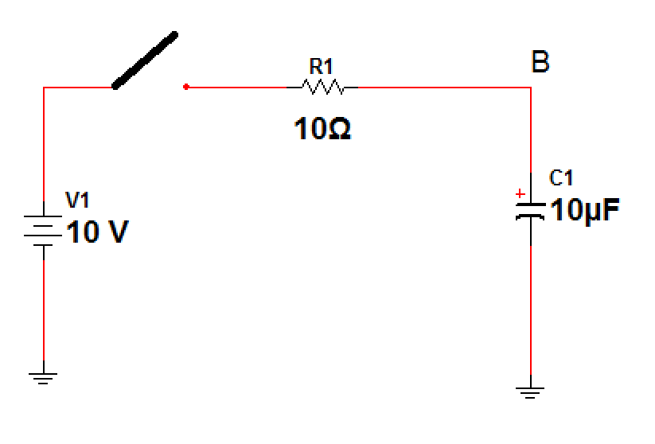

1. **if the voltage across the capacitor is zero what is wrong with the capacitor**

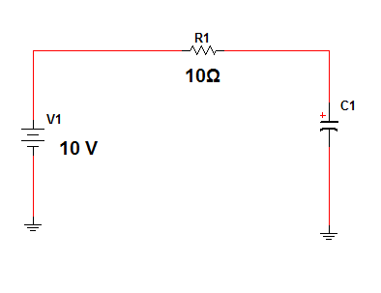

1. **in the video signal shown, what is the “A” and what is the “B”?**

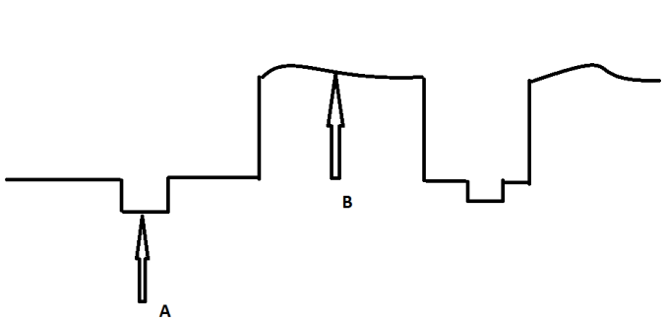

1. **in the circuit shown below, if the voltage between point “A” and ground is the same as the B+, what is wrong with the transistor?**

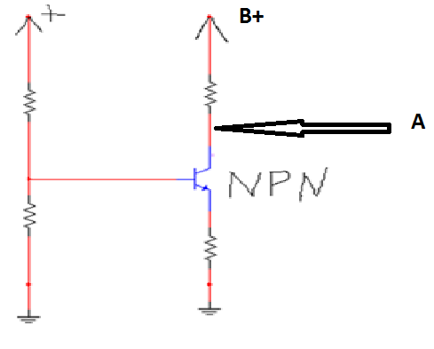

1. **A circuit was connected as shown below, and the resistor burned, why?**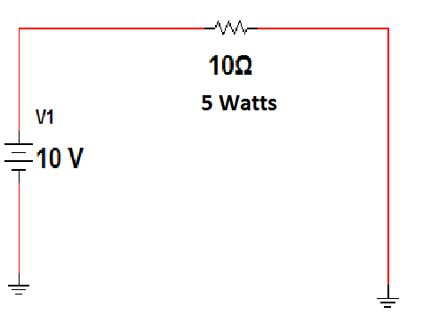
2. **what is the current through the resistor in the circuit below?**

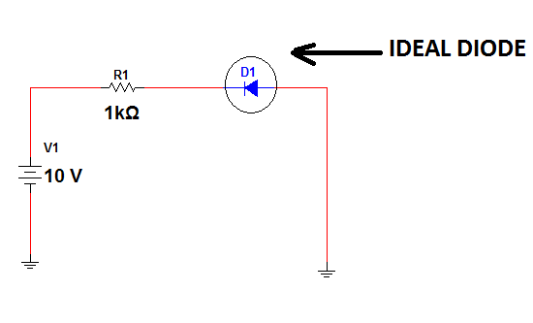

1. **What are the values of the resistors with the following color codes?**

**Brown-Black-orange =**

**Orange-orange-orange =**

**Green-blue-red =**

**Blue-gray-yellow =**

**White-orange-orange =**

*Hint: write down the color for all number(0 through 9) first and then construct the value of each resistor.*